Forest School
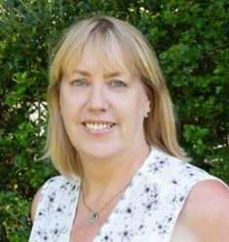

At Abbey Gates, Forest School, which is used as an approach to learning that takes children into the great outdoors to explore the natural environment, is delivered by Mrs. Miles. We use Strengths and Difficulties Questionnaires to identify children who will benefit from accessing Forest School to support their social, emotional and mental health development. The multi-sensory and enabling environment of Forest School, where children can explore and take supported risks mean that they gain independence. Taking a child-led approach encourages children to develop a sense of value and belonging. Children will build problem-solving skills, confidence, independence and resilience as they are allowed to test their limits in the natural world. A hands-on learning approach allows children to develop skills that may be difficult to teach in the classroom, assess problems and make their own decisions about how to solve situations. This way of working encourages children to build self-esteem and confidence, co-operate and communicate with their peers, understand the importance of taking care of the environment, nurture empathy and a sense of connection to nature, be inspired by the world around them and build a positive attitude to learning and motivation
Children accessing Forest School will be working towards achieving the following targets.
- I can focus independently for short periods of time.
- I can develop self-regulation skills.
- I can cope with and learn from failure.
- I can build resilience (the skill of coping with risk and failure).
- I can gain a sense of achievement.
- I can increase motivation and concentration.
- I can improve my problem-solving skills

