
Y1 Aim High Homework Project

As a class we have produced a menu with a range of activities that will support your child’s learning at home. These activities were suggested by the children and are some activities that will support our learning next half term. Children can choose from the menu below or come up with something equally as creative – we look forward to seeing their ideas! Please can the completed project(s) be brought into school or uploaded to Microsoft OneNote by Friday 29th April..

Option 1:
This half term, we have been thinking how one person can change the world. Research a person who you think has changed the world. Who are they? What did they do? How did they do it? Create a fact file all about your chosen person.

Option 2: The Easter Story (RE)
The children have loved learning all about the Easter Story in RE. Can you retell the story? You can do this in any way you’d like. E.g. writing, drawings, story maps, acting, voice recordings.
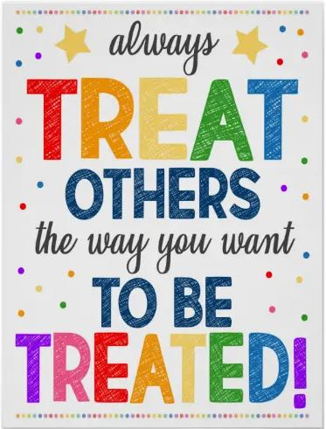
We have focused on the first 2 bees this half term (be kind to ourselves and be kind to others). You might want to show how and why we should look after ourselves and others through a poster, a drama or a dance. You could film your efforts and upload them to the One Note.

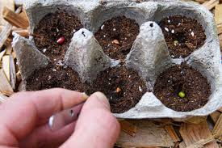

Option 3: Planting.
Plant a seed of your choice and keep a diary of what you can see each week. How much has it grown? What can you see? How tall is it in cm? Can you draw what it looks like each week?
Option 4: Baking
The children said that they wanted to celebrate Easter with lots of baking. They said they’d love to bake rice crispy cakes, chocolate next cakes or a lovely sponge cake.

