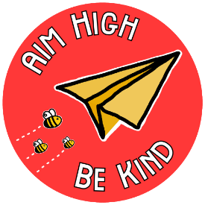
Y3 Aim High Homework Project

Friday 15th October 2021

Dear Parents and carers,

As part of our project ‘What makes the UK unique?’ we would like all the children to complete an ‘Aim High Homework Project’ over the half term holidays.

As discussed at the Y3 Parents Meeting earlier this term, we would like the project to be led by the children but supported by you. We have worked with the children to come up with some project ideas, but the choice is entirely theirs and we look forward to seeing what they decide to create!

Please send your completed project into school by Friday 5th November, so that we can share and celebrate them with the rest of the class.

Many thanks for your continued support,
The Year 3 Team

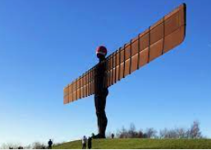
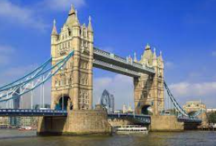
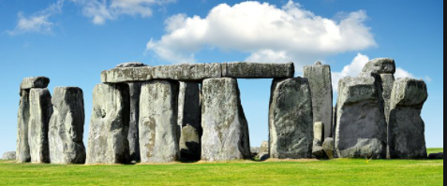
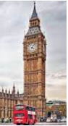
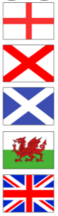
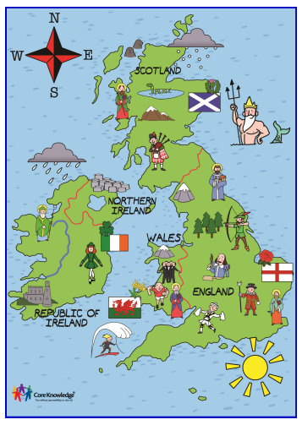
Choose a famous landmark (either one you’ve been to or would like to visit). Recreate it using junk modelling, plasticine, Lego, K-Nex or even in baking!
Find out about the flags of the UK. Research the history of the design.
You might want to design your own flag for the UK, containing the things that you think make it unique. You could draw, paint, collage or even sew your flag.
Alternatively, you might want to find out about different traditions associated with each of the countries or counties in the UK.
Put your map and compass skills to the test by planning a route around the UK. You might choose to draw your map, recording any famous sights spotted along the way.
Imagine you are on a road trip around the UK. Record your travels in a diary, remembering to write in the 1st person.
Research food recipes that are traditional to each county – write a recipe and do some cooking!

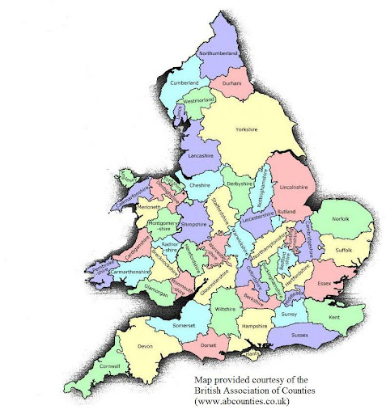
Draw or make a map of an English county of your choice – add any famous landmarks

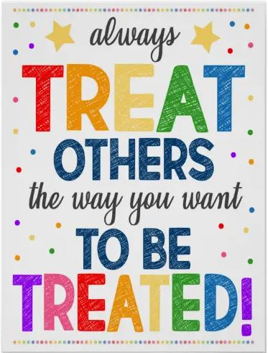
We have focused on the first 2 bees this half term (be kind to ourselves and be kind to others). You might want to show how and why we should look after ourselves and others through a poster, a drama or a dance. You could film your efforts and upload them to the One Note.

