

Year 4 Spring Newsletter
Explore Project

Welcome back and a very Happy New Year to you all. We hope that you have had a wonderful Christmas break.

EXPLORE PROJECT

We are all set for an exciting term as we explore the Earth’s mountains and rivers. Children will be asked the Big Question ‘How does the Earth’s surface change?’ A study of the Earth’s amazing physical features and where they are located around the world will help to inform our responses to the question. Just some of the exciting things we have planned include exploring the longest river and the highest mountain in the world as well as exploring the journey of water.
You can find our project placemat on the Year 4 class page on the school website, which can be used to support, revise and embed learning at home. We hope to bring you exciting news about upcoming opportunities to enrich our Explore project… watch out for a letter with more information soon!
English
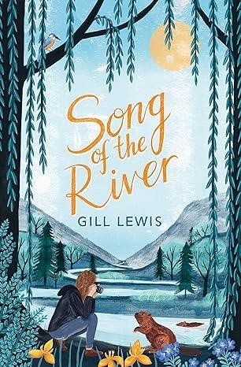
In English, we will be reading the sensational ‘Song of the River’ by Gill Lewis. This high-quality text will support our Explore project teaching the children about environmental fragility as the main character, Cari tries to persuade her community to allow beavers to be reintroduced to their valley in the hope of averting catastrophic floods. An exciting opportunity for the children to explore and embed new vocabulary! Please ensure children are reading regularly at home and filling in their reading diaries as well as practising and completing the weekly spelling homework to support our English curriculum.

Maths

In maths, we continue to follow the White Rose programme of work. This term we will focus on:
- Multiplication and Division
- Length and Perimeter
- Fractions
- Decimals

By the end of Year 4, children are expected to know all of their times tables up to 12x12, which is essential for future success in mathematics. Please support your child at home by ensuring they continue to practise their times tables. We recommend the Soundcheck game on TT Rock Stars which replicates the statutory multiplication check, which will take between the end of May and the beginning of June 2026.

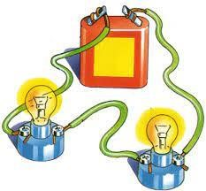
SCIENCE
In science, we will be learning about electricity and then sound with lots of exciting opportunities such as building a functional circuit to create a torch in our DT project and experimenting with vibrations in music.

WIDER CURRICULUM

This term, we continue with our work on the Zones of Regulation in RSHE lessons. You can find some of our children talking about this on the school website Click here to hear more about the Zones of Regulation.

In computing, we are learning how to create spreadsheets, which will supplement our maths curriculum. In art children will explore shades and tones, experimenting with light and dark. Year 4 pupils will continue to develop their understanding and vocabulary in French, learning how to create word profiles to describe themselves. In RE the question ‘What is the deeper meaning of religious festivals?’ will be posed as the children explore a range of celebrations which take place throughout the year.

PE will continue to take place with Mr Martin on Monday and Thursday afternoons beginning with dodgeball and badminton. Children should continue to come into school in their correct school PE kits on these days. Please ensure that long hair is tied back on these days and that children are not wearing any jewellery (including earrings).


DT
During the Spring term, the children in Year 4 will put their teamwork and baking skills to the test as they learn the steps needed to make a biscuit from scratch. They then look to see how the recipe can be adapted to make the original even more scrumptious!


PRODUCTION
Later in the term the Year 3 and 4 children will be putting their music and drama skills to good use and showcasing their talents in the lower key stage 2 performance. We can’t wait to share exciting details about this with you.

CAN YOU HELP?

Are you able to help with any of our curriculum? Do you have any skills/talents linked to the things we are learning? Perhaps you know somebody who has a geography-based career who might be able to come in and inspire us? Please let us know! We would love to invite you in. In order for us to provide the materials required for baking, we ask for contributions to our enrichment fund. These can be made via the school gateway. We thank you in advance for your support.
We are also seeking volunteers to assist with reading across all year groups. If you are available to lend your support, please let us know. Your help can significantly improve reading development and any assistance would be greatly appreciated. We can be flexible with days and times. Please don’t hesitate to come and talk to us should you have any questions.

Thank you for your continued support
YEAR 4 TEAM



