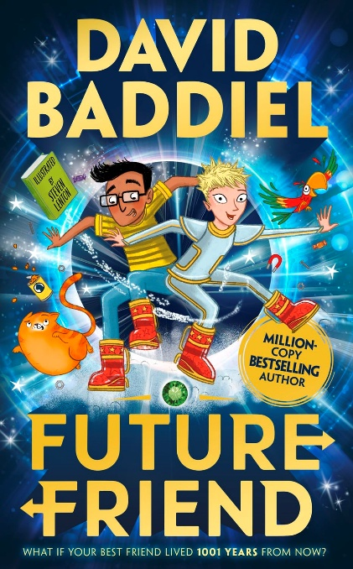

The year is 3020.
Pip@256X#YY.3_7 is lonely and bored: she goes to virtual school on her G-Glasses, she only has a talking cat and parrot to hang out with, and she can’t even leave her LivingSpace due to the extreme heat and floods outside.
Until the day that Pip explores a glowing ring in a lab and finds herself in a warehouse, in 2019.
Where she meets boy-inventor Rahul – who is also lonely and bored.
Together, Rahul and Pip are no longer lonely. But they have a whole load of new problems, including hiding talking animals from Rahul’s parents, and finding a way back to the future.

