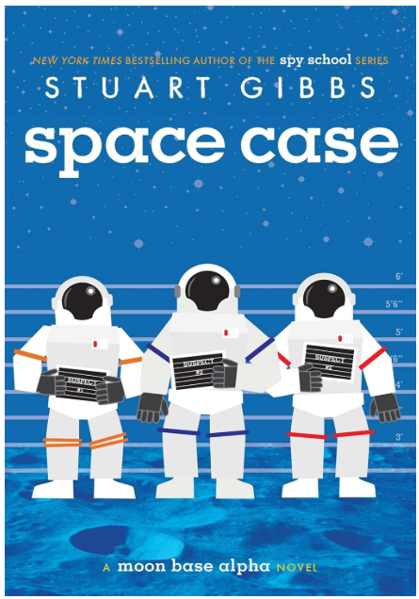
Like his fellow lunarnauts--otherwise known as Moonies--living on Moon Base Alpha, twelve-year-old Dashiell Gibson is famous the world over for being one of the first humans to live on the moon.
And he's bored out of his mind. Kids aren't allowed on the lunar surface, meaning they're trapped inside the tiny moon base with next to nothing to occupy their time--and the only other kid Dash's age spends all his time hooked into virtual reality games.
Then Moon Base Alpha's top scientist turns up dead. Dash senses there's foul play afoot, but no one believes him. Everyone agrees Dr. Holtz went onto the lunar surface without his helmet properly affixed, simple as that. But Dr. Holtz was on the verge of an important new discovery, Dash finds out, and it's a secret that could change everything for the Moonies--a secret someone just might kill to keep...

