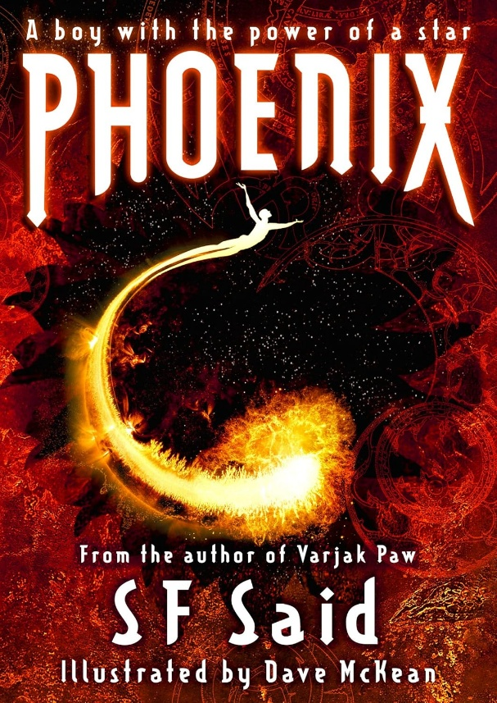

Lucky thinks he's an ordinary Human boy. But one night, he dreams that the stars are singing to him, and wakes to find an uncontrollable power rising inside him.
Now he's on the run, racing through space, searching for answers. In a galaxy at war, where Humans and Aliens are deadly enemies, the only people who can help him are an Alien starship crew – and an Alien warrior girl, with neon needles in her hair . . .

