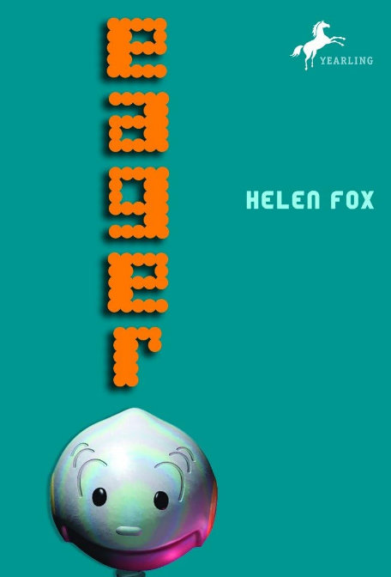

It's the end of the 21st century where technocrats rule and robots take care of humans' every need. Your house watches you, knows your secrets, and talks to you. And your closest friend can be--a machine?
Gavin Bell and his teenage sister Fleur come from a middle-class family. Their much-loved, old-fashioned robot, Grumps, is running down and can't be repaired, so a scientist friend loans them EGR3, an experimental new robot to help Grumps. EGR3, known as Eager, learns from his experiences, as a child would. He feels emotions--wonder, excitement, and loss. When the ultra high-tech, eerily human BDC4 robots begin to behave suspiciously, Eager and the Bells are drawn into a great adventure that is sometimes dark and often humorous. As Eager's extraordinary abilities are tested to the limit, he will try to find the answer to this question: What does it mean to be alive?

