
Planning sheet

Begin your non- chronological report with an introduction of what you will be reporting on.
Introduction- Title:
Paragraph 1.
Subheading:
Paragraph 2
Subheading

Paragraph 3
Subheading:
Pictures/facts to include: link to which paragraph?

Conclude the explanation text
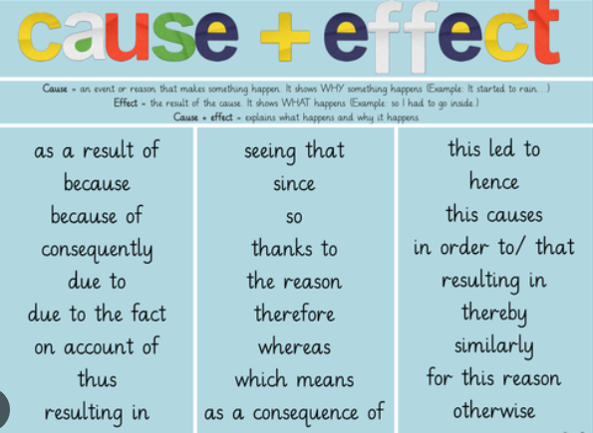
In conclusion/ To conclude……
Use the following words and phrases to help you link paragraphs and structure your writing:

