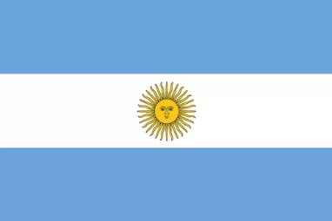
Argentina

Population: About 46 million people live in Argentina (2023)
Capital: Buenos Aires has a population of about 15 million people
Name: República Argentina or Argentine Republic, Argentina means 'land of silver'
Language: Spanish, Italian, English, German, French and indigenous languages

Landmarks and Attractions
Buenos Aires: The capital city and most populous city with cafes, restaurants and the tango. Places to see in Buenos Aires include the la Boca district with its colourful buildings, or the city centre.
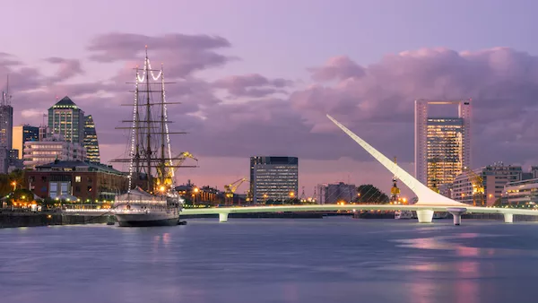
Mendoza Wine Region: This beautiful area with the Andes mountains in the background has the best wines in Argentina and is one of the biggest wine producing areas in the world.

People
One third of the population in Argentina live in the capital city Buenos Aires. 92% of the people live in urban centres, which means cities and towns.

The biggest cities in Argentina are Buenos Aires, Cordoba, Rosario and Mendoza. Patagonia is only sparsely populated.

In Argentina, herders on horseback called 'gauchos' look after the large herds of cattle or sheep.



