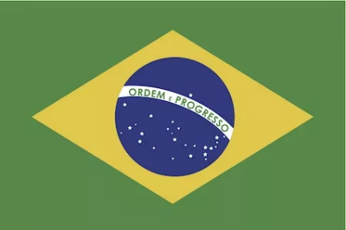
Brazil

Population: 219 million people live in Brazil (2023)
Capital: Brasilia, with 5 million inhabitants is the country's fourth largest city. The largest city in Brazil is Sao Paulo with about 23 million inhabitants.
Name: República Federativa do Brasil, Federative Republic of Brazil
Language: Portuguese

Landmarks and Attractions
Rio de Janeiro: Copacabana and Ipanema are great for beach holidays
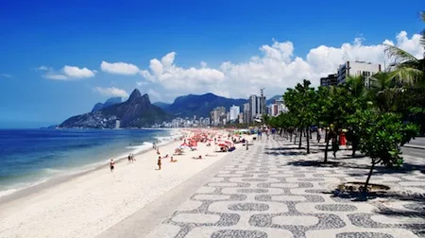

Capivara National Park is known for ancient rock paintings
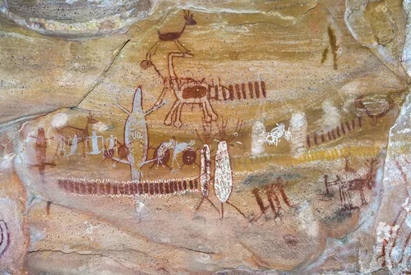

Recife, the country's fourth largest city is also nicknamed 'Venice of Brazil' because of its over 50 bridges and many waterways. 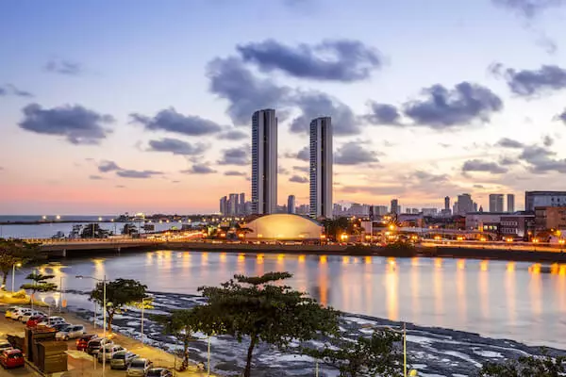

People
Brazil is the country with the fifth largest population in the world, after China, India, the USA and Indonesia.

Most Brazilians (87%) live in urban centres, mainly along the Atlantic coast and in the major cities.

The biggest cities in Brazil are Sao Paulo, Rio de Janeiro and Brasilia. The Brazilian cities are known for the extensive favelas. These are the neighbourhoods or shanty towns, where mainly poor people live.
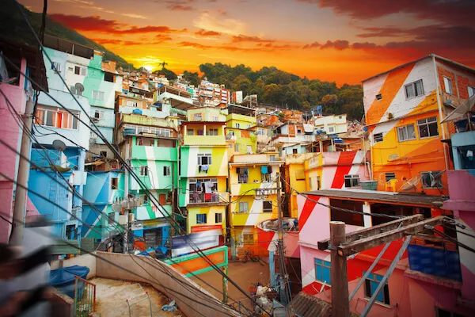

Among the Brazilian people are more than 800,000 indigenous people, some of them Amerindians.



