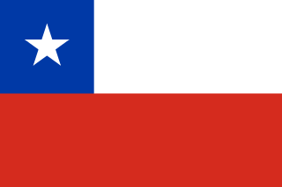 Chile

Population: 19 million people live in Chile (2023)
Capital: Santiago, with almost 7 million inhabitants is the country's largest metropolitan area
Name: Republic of Chile
Language: Spanish

Landmarks and Attractions
Santiago: Chile's capital city houses the Gran Torre which is the tallest building in South America with 64 floors. Gran Torre means 'big tower' in English.
Easter Islands, also called Rapa Nui, is famous for the magnificent statues, which are called moais.
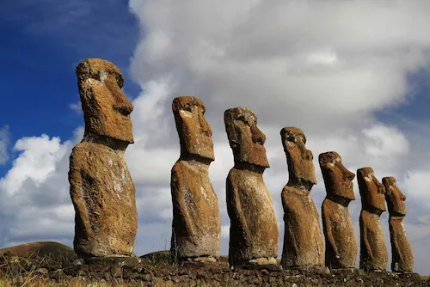
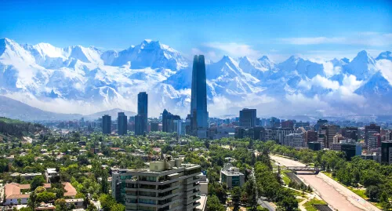

Chilean People
Three out of four Chileans live in central Chile.
The majority of Chileans (85%) live in urban areas.
Most Chileans are of mixed Spanish and native American ancestry, however, today only 30% refer to being mestizo (of mixed ancestry) and 11% refer to belonging to indigenous groups.
The biggest indigenous group are called Mapuche. Other indigenous groups are the Rapa Nui on Easter Island or the Aymara people.


