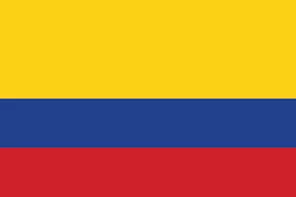
Colombia

Population: More than 51 million people live in Colombia (2022)
Capital: Bogotá with 11 million inhabitants is the country's largest city
Name: República de Colombia or Republic of Colombia.
Language: Spanish

Landmarks and Attractions
Bogotá: the country's capital city has a beautiful old centre called La Candelaria with 300 year old Spanish colonial buildings. There are also graffiti and street art to be admired throughout the city. The artists are actually sponsored by the Colombian government!
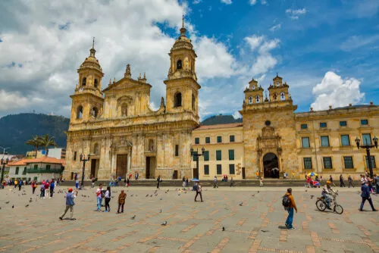

Colombia is rich of natural resources such as petroleum, natural gas, coal, gold and copper. The country's biggest trading partner is the USA.

Coffee is also a main export product and Colombia is the world's third biggest exporter.

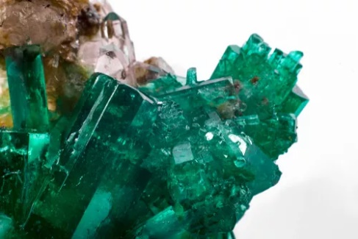
The country is also famous for its magnificent emeralds, which are bright green gemstones.

People
Colombia is the second most populous country in South America. Colombia is a Spanish speaking country, but various Amerindian, Creole and Romani languages are spoken as well. In fact more than 75 indigenous languages are used in Colombia.
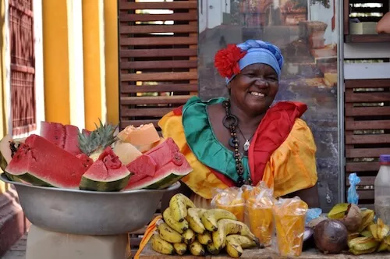
Most Colombians live in the northern and western regions of the country, in the Andean highlands near the capital city Bogotá or near the Caribbean coast.

