Peru
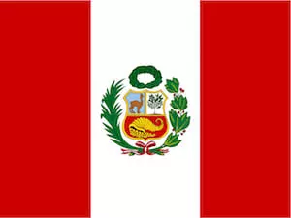
Population: 33 million people live in Peru (2023)
Capital: Lima with 10.8 million inhabitants
Name: República del Peru (Republic of Peru)
Language: Spanish, Quechua, Aymara

Landmarks and Attractions

Lima: The capital city of Peru is called Lima. This city was once referred to as La Ciudad de los Reyes, which means 'City of the Kings'. Lima was the capital of the Inca and later during the early Spanish colonialisation, the capital of the viceroyalty.
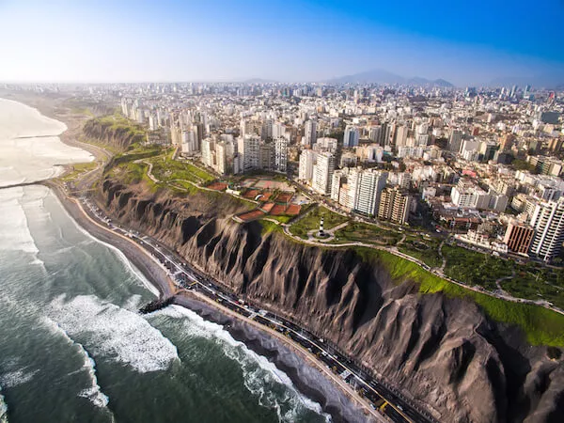
Machu Picchu: The ruins of the ancient Inca empire are located at about 2,500 m/ 7,972 ft high up in the mountain forests.
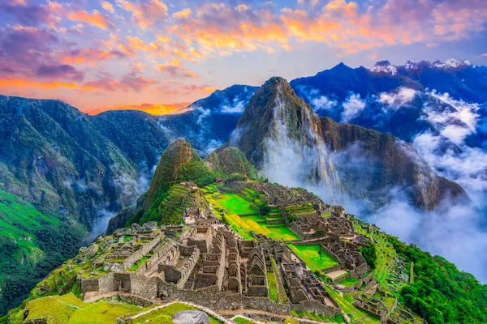
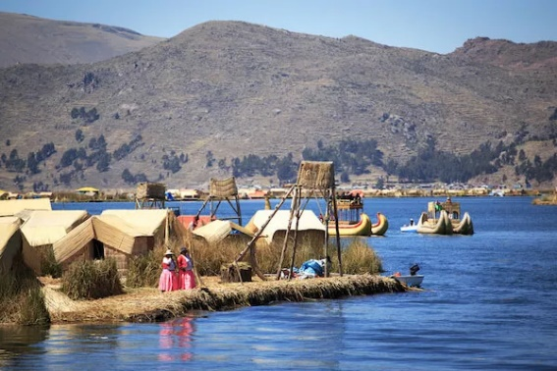
Lake Titicaca: The floating islands in the world's highest navigable lake are made from many layers of reed that are constantly refilled and reworked. The Uros people living in the region are known to construct huge figures and floats from reeds to attract visitors to the islands.
People
Many Peruvians live in the coastal area of the country, especially around the capital city Lima, and the Andes Mountain region. Most of the population (78%) live in urban centres. The eastern part of the Andean region and the rainforest area in the east is only sparsely populated. 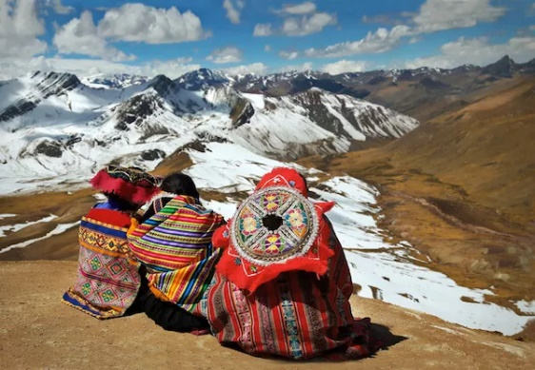
Almost a quarter of the population (23%) lives below the poverty line. Poverty and income inequality affect mainly the rural population or the indigenous people
Most Peruvians are of mixed white and native American ancestry, about 60% are referred to as mestizo (of mixed ancestry). 

