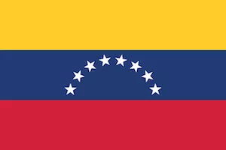
Venezuela

Population: 30 million people live in Venezuela (2022)
Capital: Caracas with 3 million inhabitants
Name: Bolivarian Republic of Venezuela
Language: Spanish

Landmarks and Attractions
The statue of the Virgin Mary of Trujillo is the highest statue in the Americas. It is taller than the Statue of Liberty in New York!
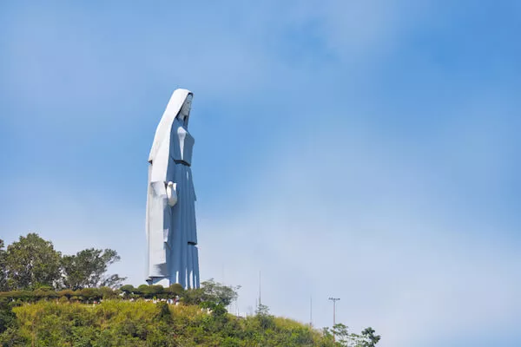
Esfera Caracas 360, in English called "Caracas Sphere", is a famous sculpture by artist Jesús Soto. The sculpture offers optical illusions when walking around it. The 'Soto Sphere' is seen as a symbol of the capital city.
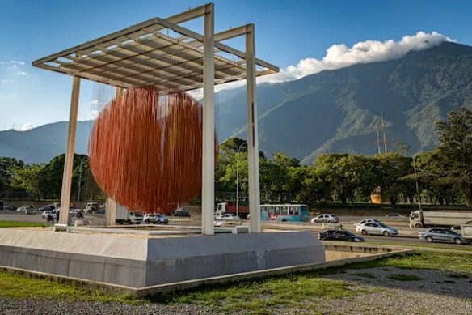

People
Among the indigenous population of the area are the Timoto-Cuicas, the Kalina and the Mariche people.
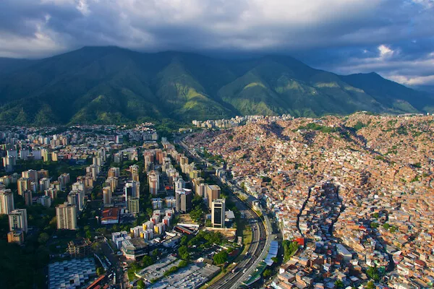

Caracas is the largest urban area in Venezuela and houses about three million people. Most of the Venezuelans live in the northern and western highlands.

Economy
The country has large resources of petroleum, natural gas and minerals such as iron ore or gold. Still the population in the country is very poor, almost nine in ten people suffer from poverty and hunger.


